Qasr Limited: Carbon Reduction
Supplier name: Qasr Limited
Publication date: 5/10/2026

Commitment to achieving Net Zero

Qasr Limited is committed to achieving Net Zero emissions by 2050.

Baseline Emissions Footprint
Baseline emissions are a record of the greenhouse gases that have been produced in the past and were produced prior to the introduction of any strategies to reduce emissions. Baseline emissions are the reference point against which emissions reduction can be measured.

Baseline Year: 2025/2026 (financial year 1st of February 2025 to 31st of January 2026)
Additional Details relating to the Baseline Emissions calculations.
Emissions are reported in three scopes as defined by the Greenhouse Gas protocol. All figures are in tCO2e: tonnes of carbon dioxide equivalent. This is the standard unit that combines all greenhouse gases into one number.

This is Qasr Limited’s first carbon footprint. Emissions have not previously been assessed or reported, so the first reporting period is used as the baseline.

Scope 1 (Direct Emissions from fuel burned in vehicles, boilers or equipment the organisation owns): Qasr Limited does not own or operate any premises, company vehicles or other equipment that would use fuel. Subsequently, Qasr’s emissions for this scope is Zero.

Scope 2 (Emissions from electricity, heat or cooling bought for premises the organisation controls): Qasr’s staff work from home or at client sites, no electricity, heat or cooling is purchased for any premises as Qasr owns none. Subsequently, Qasr’s emissions for this scope is Zero.

Scope 3 (Emissions the organisation causes at sources it does not won or control, such as travel by train, plane or staff’s own cars): 8.99 tCO2e.

The GHG Protocol divides Scope 3 into fifteen numbered categories. The Government’s PPN 006 Technical Standard requires five of them to be reported and keeps their original numbers. The below list reflects Qasrs position on each of the categories.

Category 4, Upstream transportation and distribution (Emissions from delivering goods that Qasr purchases): The purchases that Qasr limited makes are limited to occasional postage and IT equipment, so this is considered immaterial.

Category 5, Waste generated in operations (Emissions from disposing of Qasr’s waste): This number is not quantified, this is because waste is limited to home-office items. Qasr’s Carbon Management Policy commits to minimising waste and encouraging recycling, and its ESG policy to reduced and recycled paper.

Category 6, Business Travel (journeys made for work in vehicles Qasr does not won): 7.74 tCO2e. This covers rail, the London Underground, mileage in staff’s own cars, taxis, flights and hotel stays. Three long-haul return flights account 4.03 tCO2e of this.

Category 7, employee commuting, including home working: 1.25 tCO2e. Qasr has no office, therefore is no commuting to a Qasr workplace. The figure covers energy used when staff work from home, which the Technical Standard allows to be included here.

Category 9, downstream transportation and distribution (emissions from delivering goods that Qasr sells): Qasr provides consultancy services and sells no physical goods. This category is therefore not applicable.
How the figures were calculated: Each journey, hotel stay or day working from home was multiplied by the matching UK government conversion factor for 2025. Business travel comes from staff expense claims. Where a claim only recorded the cost of a journey, the distance was estimated from the route or the fare.
Not Included: IT equipment bought in 2025/2026 (estimated at 0.16 tCO2e). This falls under Scope 3 categories 1 and 2 (purchased goods), which are not among the five required.
Baseline year emissions:
EMISSIONS | TOTAL (tCO₂e)
Scope 1 | 0.00
Scope 2 | 0.00
Scope 3 (Included Sources) | 8.99
Total Emissions | 8.99

Current Emissions Reporting
Reporting Year: 2025/26 (same as baseline year)
EMISSIONS | TOTAL (tCO₂e)
Scope 1 | 0.00
Scope 2 | 0.00
Scope 3 (Included Sources) | 8.99
Total Emissions | 8.99

Emissions reduction targets

In order to continue our progress to achieving Net Zero, we have adopted the following carbon reduction targets.

We project that carbon emissions will decrease over the next five years to 7.19 tCO₂e by 2030/31. This is a reduction of 20% against the 2025/26 baseline of 8.99 tCO2e. The figure follows a direct path from the baseline to net zero by the target date of 2050. This will be continually recalculated as data and Government conversion factors are updated.

Progress against these targets can be seen in the graph below:

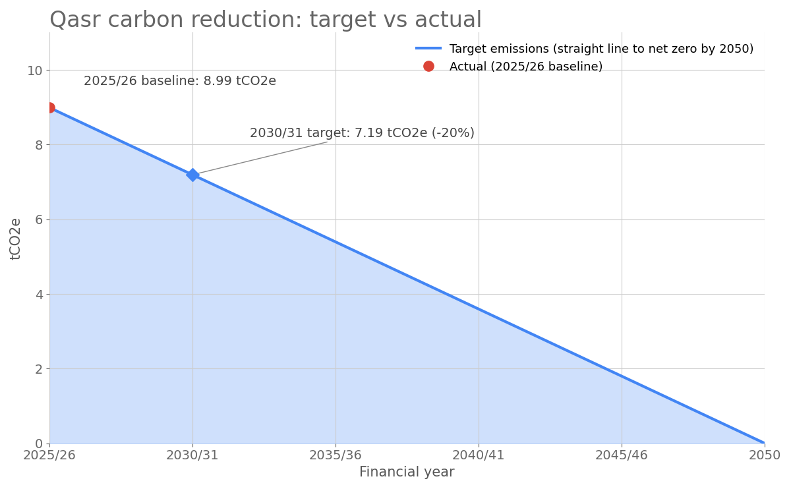

Carbon Reduction Projects

Completed Carbon Reduction Initiatives
The following environmental management measures and projects have been completed or implemented since the 2025/26 baseline. The carbon emission reduction achieved by these schemes equate to 0 tCO₂e, a 0%ge reduction against the 2025/26 baseline and the measures will be in effect when performing the contract.
As 2025/26 is Qasr’s first reporting year and also its baseline, there is no earlier year to compare against, so the reduction figures above are zero. The four policies below were authorised by a Managing Partner in July 2026, after the baseline year. The two arrangements below these new commitments were already in place during the 2025/26 reporting period. All of the below will remain inn effect when performing the contract:
- Carbon Management Policy (Authorised 18th July 2026): This policy commits Qasr to prioritise virtual meetings to reduce travel, and where travel is necessary, to use public transport is where feasible. This policy encourages Qasr to use route-efficient and low-carbon travel choices whilst also promoting energy-efficient behaviours in when in home-working environments. There is also a commitment to minimise waste and encourage recycling, and to also utilise digital documentation so as to avoid the needless usage of paper. Qasrs Carbon Management Policy commits the company to providing carbon literacy training, and to prepare for full scope 1, 2 and 3 emissions tracking.
- Environmental Policy (Authorised 12th July 2026): This Policy uses ISO 14001:2015 as the framework for environmental protection. It also commits Qasr to prioritise sustainable suppliers, minimise waste by buying only what is required, and comply with client’s environmental systems and procedures when working for them.
- ESG Policy (Authorised 12th July 2026): The ESG policy commits Qasr to use public transport for all client site visits where possible, reduce paper usage by utilising electronic documentation and by also using recycled paper where printing is necessary. This policy also encourages Qasr to be mindful of energy efficiency when working from home or on client premises.
- Energy Management Policy (Authorised 18th July 2026): This policy Commits Qasr to using energy-efficient IT equipment with automatic sleep and power-down settings, prioritise virtual meetings, as well as encouraging low emission travel alternatives such as cycling or public transport.
- Home-based operating model (In place during the 2025/26 baseline): Qasr has no office premises, which avoids the energy use of a dedicated office and daily commuting to it.
- Rail as the main way staff travel to clients (In place during the 2025/26 baseline): in 2025/26, rail made up about 62% of the distance travelled by rail and car combined.

Future carbon reduction initiatives
In the future we hope to implement further measures such as:

- Working towards ISO 14001:2015 certification, building on the Environmental Policy’s use of the standard as its framework.
- Recording journey details, including start, destination, mode and class, on expense claims so that future footprints can have more accurate measurements. This Supports the Carbon Management Policy commitment to prepare for full emissions tracking.
- For long-haul trips, reviewing whether the trip is needed and could instead be attended virtually, combining visits, and using economy class.

